[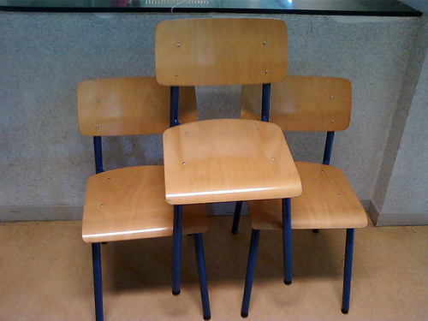](https://www.google.nl/url?sa=i&rct=j&q=&esrc=s&frm=1&source=images&cd=&cad=rja&uact=8&ved=0CAcQjRw&url=https%3A%2F%2Fwww.flickr.com%2Fphotos%2F59256958%40N03%2F5839343193%2F&ei=hiH2VPHcN8H0UsG9g8gJ&psig=AFQjCNGFHoNrVMFRHuv6wfWPa1-OAx_4Yw&ust=1425502827554096)[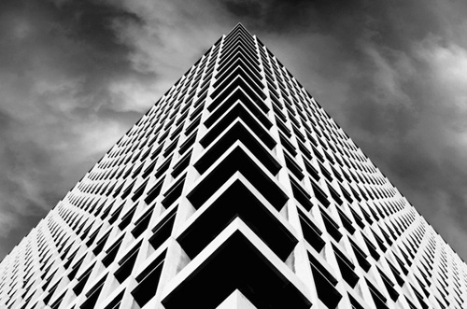](https://www.google.nl/url?sa=i&rct=j&q=&esrc=s&frm=1&source=images&cd=&cad=rja&uact=8&ved=0CAcQjRw&url=https://www.pinterest.com/imkegoedhart/handvaardigheid-fotografieopdracht/&ei=vyH2VPXsOon9Uo6kg-AJ&psig=AFQjCNGFHoNrVMFRHuv6wfWPa1-OAx_4Yw&ust=1425502827554096)

[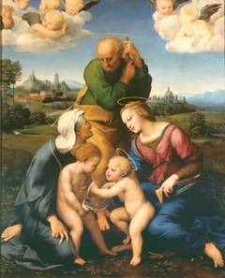](http://www.google.nl/url?sa=i&rct=j&q=&esrc=s&frm=1&source=images&cd=&cad=rja&uact=8&ved=0CAcQjRw&url=http%3A%2F%2Fwww.gerardenneeltje.nl%2FKunst%2Frenaissance%2FKenmerken%2520van%2520de%2520schilderkunst%2520inde%2520Renaissance.htm&ei=VyH2VPW2NoH9UsXvgtAD&psig=AFQjCNGFHoNrVMFRHuv6wfWPa1-OAx_4Yw&ust=1425502827554096)Driehoeks

Compositie